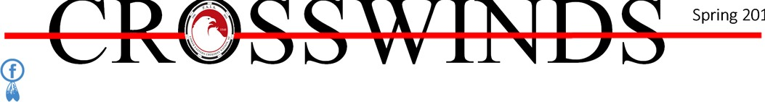9

Piedmont American Indian Association Lower Eastern Cherokee Nation 3688 Warrior Creek Church Road, Gray Court, SC 29645

Osiyo,
Chief’s Corner

Spring has sprung or so I am told, although some days it feels like Old Man Winter pops up again. Then it seems as if it is summer, then back to the fluctuating temperatures.
Evidently Old Man Winter isn't ready to give in to Mother Nature or vice versa. I don't know about you folks but I am ready for warmer weather and hoping the yellow dusting from Mother Earth will soon disappear.
I hope this spring newsletter finds all our tribal members doing well, both physically and mentally. I know we all have mood cycles with certain seasons and with the bouncing that is going on right now, we may not know what mood to be in!
The tribe has been busy attending certain events and starting our Kids Days with area schools. But again Mother Nature intervened by raining out our last two Kids Days.
We are crossing our fingers for the next couple of sched‐ uled Kids Days.
I would like very much to thank our Tennessee members who came down to work on the tribal grounds on March 9th. We had a great time working together. The hambur‐ gers and hot dogs grilled by Two Blades were outstanding. The fellowship was great and seeing the children helping was heartwarming.
Some of our tribal women, including myself, attended the 2nd Annual Indigenous Women's Conference in Columbia on February 9th. This was sponsored by the Indigenous Women's Alliance of South Carolina. They also had a "Women of Strength” Unity Ceremony honoring some of our Native American Women who had been recognized during the past year. We were honored to have one of own tribal women present, Eﬃe "Woman Who Speaks Her Mind " Altman was the first honoree in April of 2018. Ms. Eﬃe just celebrated her 91st birthday in March.
I was invited as a guest in January to The Confederate Colonels Club in Greenville, SC. I spoke last year to one of the Sons of the Confederacy Chapters on the role of Native Americans and the Cherokees during the Civil War.
On February 20th, I attended the 14th Annual Native American Studies Week at the USCL Native American Stud‐ ies Center in Lancaster, SC. We started oﬀ with the annual Chiefs Luncheon followed by the presentation of the Was‐ samasaw Tribe of Varnertown Indians. Their tribal history and info will be on display until February 15, 2020.
Our tribe had a display in 2016. Displaying the history of some of the South Carolina Indian Tribes is an honor and an educational event.
Our tribe was invited to participate in the Annual Issaqueena Festival in Six Mile, SC, on April 6th. I want to thank Vice Chief Dexter Sharp, Beckie Sharp, Two Blades Williams, Patsy Durham, Kimberly Lance, Creeping Fox Rid‐ dle and Sequoah Red Cloud Riddle for participating. Also thanks to our photographer, Tommy War Dog Sanders and Brenda Sanders.
I was unable to attend due to recuperating from ear sur‐ gery on April 3rd. I don't know what our tribe would do without these tribal members giving up their Saturday to drum, dance, sell crafts and mingle with the crowds. Thank you all for your dedication.
On Friday, April 12th, Victoria Norris, Patsy and Gene Durham and I attended the annual gala at the Laurens County Museum. We enjoyed a great dinner and music from the sixties.
I hope I have not left anything or anyone out. Looking for‐ ward to some dry Fridays coming up for the rest of our Spring Kids Days. I am having to slow down some during my surgery recuperation and I am not one who knows how to slow down, but I am learning!!
Wado,
Chief Worthy

CROSSWINDS Spring 201

Any change of your address, email address, phone number please contact us to let us know of the change as soon as possible by calling 864‐967‐2713 or 864‐683‐1421 (tribal oﬃce) If you have email the tribe will save almost $4.00/person per quarter.
Contact Chief Worthy @ cherokeesister@msn.com , or 864‐871‐9058

Piedmont American Indian Association Lower Eastern Cherokee Nation SC
3688 Warrior Creek Church Road, Gray Court, SC 29645

864‐683‐1421
Chief Mary Louise Wolf Woman Worthy Vice Chief Dexter Yellow Hawk Sharp Tribal Council
Harold Lone Wolf Norwood Mark Two Blades Williams Gene News Carrier Durham Barbara Raven Sanders Scott Red Otter Gephart
Museum and Kids Days Program:
Victoria Yellow Rose Norris
Craft store: Beckie Morning Sun Sharp and Kimberly Night Bird Lance
Red Shirt Warrior Society: Mark Two Blades Wil- liams
Elders Council: Patsy Dancing Wolf Durham
Warrior Creek Youg Cherokees: Kimberly Night Bird Lance
www.paialecherokeenationsc.com
Piedmont American Indian Association is a 501(c)(3) non profit organization and is proudly affiliated with the following.

South Carolina Indian Aﬀairs Council

Indigenous Women’s Alliance of SC

Hello. I, Mark Two Blades, was sanctioned as a "Fire Keeper," then as the "Fire Keeper" for our tribe on Jan 18, 2019. Since then I was asked to come to The Women Of The Eastern Drum Gathering to keep a "Fire " for this event. I was hon‐ ored to do this. There was such an amazing feeling of positive energies and wellness around these women. They had about twelve women drum teams and it was great. They honored me for being the "Fire Keeper" for them and made sure I had food and drink. I kept this fire for 13 hrs. If you can imagine, twelve drums with four to eight women on each drum, play‐ ing and harmonizing together. It was breathtaking. MAN, can these women play their drums. They spoke their vri‐
ous languages from the tribes they came from. They told me they are bringing back the old family and spiritual songs. They don't really sing what is called Pow Wow music. They leave that for the men to do. I have kept many "Fires" before, Kids Days, other tribe’s Pow Wows and gatherings, our Pow Wows, equinox and solstice fires as well . This one was diﬀer‐ ent. When these women came to the "Fire" to be smudged and entered the circle, it seemed the "Fire" got bigger and brighter without more wood.
Anytime I do a "Fire," I always use the proper woods and teachings as I was taught to do. I keep in mind something that First Chief Norris told me one time. He said, "Two Blades, when you go out into the world you must remember that you are representing us, your tribe, the PAIA. ALWAYS represent us well. Be mindful of your words and actions. People will remember what they see and hear and this will be the image they associate with our tribe." I have been asked again to keep a "Fire" for the Pee Dee Gathering in May. Always a good time to share stories and bond these tribes together.
The "Fire " keeps us grounded with Mother Earth and Grand‐ father Sky, the Creator. I think all tribes should have a "Fire Keeper." If they don't and want one, I feel it’s my duty to try and help them. Chief Parr is a good and kind man. I like help‐ ing people like this. Going to these other events helps spread a good Cherokee image. Chief Norris also said, "If you want to enjoy a Pow Wow, go to someone else's. You WORK at ours." I miss him greatly. So, go to some of the other Pow Wows and help support our brothers and sisters.
We will talk again. Learn, Teach and Help each other. "Fire Keeper"
Mark Two Blades Williams

OTHER TRIBAL NEWS

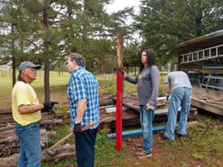 RED SHIRT WARRIOR SOCIETY— The Red Shirt Warrior Society (RSWS) and I have been working hard to maintain our buildings and grounds. Gene Spoone and his crew, or as I like to call them, “Spoone Inc.” have done a great job painting the long house, shop and lawn mower
V C Dexter Sharp, Roy Moore, Whitebuﬀolo Moore
shed. Mr. Spoone has also been keeping the grass cut. We worked on the grape arbor, re‐ moved trees and shrubs and ran new posts and line for the vines to grow on. The RSWS worked on a lot of projects and had a VERY successful work day in April. Projects included the entry to the living village, moved the fire wood used for the "Sacred Fire" and cut more wood for future fires. Last week I cooked for those members that came to work. We had a blast doing the jobs at hand. Some of our Tennessee members came down and helped us with our long list of projects also. What a great group they are. So much good spirit, laugh‐
ter and hard workers. We have a lot of tasks still remaining so I'm asking any male, 14 yrs old or older, that wants to be part of something important, to come join us. There is a lot we can teach you about the tribe and about life. Talk to us. We want to hear what you have to say. We usually meet the second Saturday of the month. See you all soon. War Chief Mark Two Blades Wil‐

WOMEN OF THE SPIRIT — Meet the second Saturday each month. We would love to have you join us and can get in touch through Chief Worthy

WARRIOR CREEK YOUNG CHEROKEES— The young Cherokees have been busy this month. Some of the young Cherokee who live in Tennessee were able to assist the RSW in working outside at their last meeting. Scott please tell them thank you on our behalf. We would also ask that you tell the other mem‐ bers of your family that attended that day thank you as well on behalf of the Young Cherokees. We were also able to represent our tribe at the Issaqueena Festival in Six Mile, SC, a few weeks ago. It was wonder‐
ful to be able to have two of our Young Cherokees members dancing during our program. Thank you to Joe for partici‐ pating. I know the people of the town really enjoyed seeing our program. We are looking forward to helping with the Elders Gathering in June and anything else the tribe needs us to help with. Thank you. Kimberly Lance .

Craft Store— We have had one Kids Day this Spring due to bad weather. Our wonderful Tribal members are still making and sending beautiful crafts. We also went to a Festival in Six
Mile, SC, in April and brought our craft booth. We met some wonderful people. Things are going well for our craft store, but we can always use more. So please use your talent and send items to sell. Thank you, Morning Sun

Bring in this coupon for a 10% discount
Paid advertisers

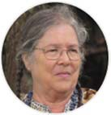
Elders Council— Elders have been busy with the upkeep of tribal property, making crafts at home and looking forward to helping during the Kids Days activities.

Pow Wow‐ A few of the performers will change this year due to some of the conflicts in scheduling. The contracts are in the process of being written and signed and we will contin‐ ue to work on the many details of the Pow Wow for the next few months.

PRAYER LIST
Vice Chief Dexter Yellow Hawk Sharp— eye surgery and is expecting a long recovery period.
Roy Cas Moore—recuperating from neck surgery.
Stacy Lazurek—recovering from a stroke.

Osiyo = (oh‐see‐yoh)= Hello *to an elder, clan mother, teacher, or other individual held in high es‐ teem or position in tribe
Wado = (wah‐doh) = Thank You

(803) 892-8367

Paid advertiser

751 Campground Rd, Gilbert, SC 29054

Tribal Member Owned Business

TEACHING CLAN VICTORIA YELLOW ROSE NORRIS

Rain has been plaguing our Howard White Bull Kids Days program since the fall…and now it’s wreaking havoc on our spring program! Our first Kids Day was March 29th, and it went very well. We had three schools: two from Laurens County and one from Greenville County, almost 300 students. Chief Worthy taught the students about our Cherokee and tribal history; Billy Lightwalker talked about pottery making and flint knapping; Elder Patsy Dancing Wolf explained the winter and summer homes and daily living in the Cherokee village; Mark Two Blades talked about the canoe and Sacred Fire; Vice Chief Sharp demon‐ strated trapping, blow gun and bow and arrow; Chief Wil‐ liam Gill joined our team teaching the students about re‐ galia and some Cherokee language; the craft station oper‐ ated by Beckie Morning Sun, Lois Fulcher, and Melanie Creeping Fox did very well selling many of our handmade crafts; Jesse Medicine Bird taught the kiddos about the Four Directions, Cherokee colors, and our flags; Gene News Carrier kept the students moving out of the long‐ house; and Terry Finely also joined our team helping where needed. Extra kudos to Gene, Jesse, and Terry for
managing the parking of the buses; and Warrior Creek Drummers for keeping those teachers dancing around the dance circle. We had two days that were cancelled and rescheduled: April 5th and 12th. We have another Kids Day coming up on April 26th (keep your fingers crossed). There are 4 schools coming with a total of almost 450 students! The rescheduled dates are May 3rd and 10th. We had to cancel our Basket Class for April 20th. It was the day be‐ fore Easter; and we didn’t get a big response. So, Deborah Moon Wolf is looking into rescheduling the class in July.
Jesse and I are working on our Strong Beaver Kids Camp which will take place on Saturday, June 8th. This camp is for our youngest members 2‐12 years of age. They will be taught the traditions and customs of their Cherokee an‐ cestors by our tribal members. They will get the oppor‐ tunity to make a craft, hear Cherokee stories, learn Chero‐ kee history and some Cherokee words; there’s a picnic and cantaloupe roll to add to the fun day! When the de‐ tails are worked out, they will be posted on Facebook.
Victoria Yellow Rose at gvnorris@charter.net.

Basket of Knowledge Museum – I am sorry to say that not much has been happening with the museum. I’ve had some personal responsibilities take over much of my time. However, I will be getti ng back on track next month. I have purchased frames to hang poster‐sized photos of our craftspeople: First Chief Norris was a flute maker, jewelry maker, and artist; Deborah Moon Wolf is an accomplished basket weaver (she has a basket in the Native Studies Museum in Lancaster); Scott Red Otter makes pipes, flutes, and whistles; Billy Lightwalker is a potter, and makes bows and arrows, and projectile points in the traditional way; Raven makes beautiful beaded and silver jewelry and stained, etched and sand‐carved glass; Mark Two Blades carves walking sticks of various woods; Vice Chief Sharp makes blow guns and darts, atlatls, and primitive bows.
Chief Worthy, Elders Patsy and Gene Durham, and I went to the Laurens County Museum Gala on April 12th. It was a night of exceptional speakers, tour of some of the Native American artifacts collection, and great food and dancing (all of us were wall flowers; no dancing for us). We have established a friendly relationship with the Laurens County Museum, and hopefully we can combine forces to work together to bring the Native American, especially the Cherokee, story to this area and beyond. Victoria Norris at gvnorris@charter.net

Oct. 4, 18, Nov. 1, 15
Sept 28
Dec. 7
Dec. 14
Christmas Gathering
fall
Kids Days Pow Wow RSWS
Howard White Bull Norris
Tribal Council Meetings May 25, Aug. 24, Oct. 26
Basket Weaving Oct 19 Strong Beaver Kids Camp June 8 Elders Gathering June 22

If you have something you want in the newsletter, send it to the tribal oﬃce (3688 Warrior Creek Church Road, Gray Court, SC 29645), or email it to sandert@sc.rr.com. Let us know what’s happening in your world so that we can share the news with other tribal members. Remember this newsletter is YOUR news!

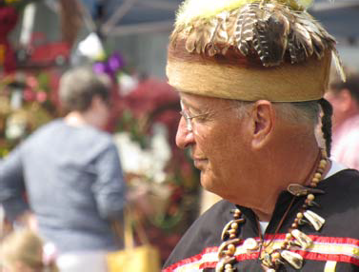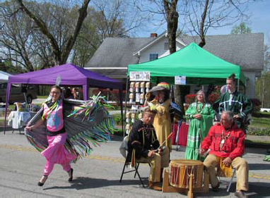Kimberly Night Bird Lance starts out with a Fancy Shawl Dance which draws attention.
Yellow Hawk and Two Blades on the drum to inspire the crowd.

Vice Chief Dexter Yellow Hawk Sharp at Six Mile SC Issaqueena Festival.
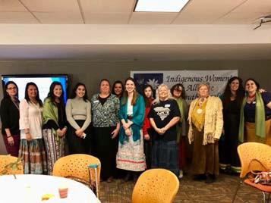
South Carolina Indian Aﬀairs Commis‐ sion Indigenous Women’s Alliance Sec‐ ond Annual Conference

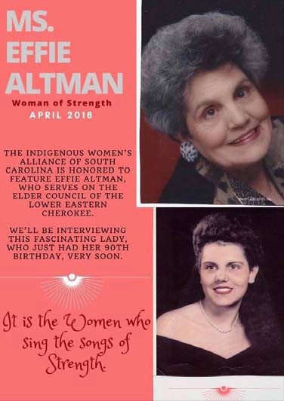
Congratulations to one of our Elders, Ms Eﬃe Altman, who was awarded Woman of Strength award from the Indigenous Wom‐ ens Alliance in 2018. Ms Altman is the mother of our own Chief Worthy

